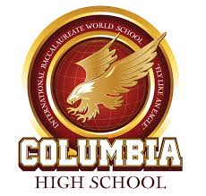
World History Honors Summer Material

Course Description
o 9th World History Honors will explore the beginnings of the Renaissance through the tensions of the Cold War. Students will discuss the politics, decisions, rivalries, and events that changed the world, as well as debate how lesson topics relate in today’s world

Course Objectives
o Discuss and research almost 500 years of world history and discover how it relates to the today o to write thought provoking essays developed from Critical Thinking Questions o to develop Critical Thinking Skills o to understand the difference between Primary and Secondary sources and create summaries based on the readings o to develop presentation skills using class projects, open debate, and discussion

Summer Work
Required Reading.
Read the two titles and write a comprehensive essay discussing; what was written? The purpose it was written for? Does it have any effects in today’s world? Minimum 3-paragraph essay for each
“95 Theses”-Martin Luther
“The Iron Curtain”-Winston Churchill

Complete the DBQs
Complete the Document Based Questions by reading the primary source and answering the questions
The Black Death
Boccaccio Describes the Black Death
Analyzing Primary Sources

