**IB MATHEMATICS**

**INTERNAL ASSESSMENT**

**STUDENT HANDOUT**

Ellen Thompson

Updated May 2020

TABLE OF CONTENTS

Page 3: THE EXPLORATION!

Page 5: DUE DATES & EVALUATION

Page 6: THE IB ASSESSMENT CRITERIA

Page 11: “NO LIST” OF TOPICS

Page 12: SUBMITTING YOUR TOPIC

Page 13: TIPS FOR WRITING A GOOD MATH EXPLORATION!

Page 16: EXPLORATION CHECKLIST

Page 18: ANNOTATING YOUR DRAFT

Page 19 APPENDIX A: LINKS TO USEFUL IB DOCUMENTS

Page 20: APPENDIX B: MATH TECHOLOGY RESOURCES

THE EXPLORATION!

**What:** A written paper that explores the math behind a personal interest of your choice

**Why:**

* To develop your personal insight into the nature of mathematics and to develop your ability to ask their own questions about mathematics
* To provide opportunities for you to complete a piece of mathematical work over an extended period of time
* To enable you to experience the satisfaction of applying mathematical processes independently
* To provide you with the opportunity to experience for themselves the beauty, power and usefulness of mathematics
* To encourage you to discover, use and appreciate the power of technology as a mathematical tool
* To enable you to develop the qualities of patience and persistence, and to reflect on the significance of you work
* To provide opportunities for you to show, with confidence, how you have developed mathematically.

C:\Users\EThomps.SJSD.LCL.000\AppData\Local\Microsoft\Windows\Temporary Internet Files\Content.IE5\9MY3TEVR\MC900384188[1].wmf

**Specifics:**

* 12-20(ish) pages
* Written in 12pt double spaced font.
* Should take around ~10 hours outside of class time. This includes research, writing a draft, editing, etc.
* All sources must be cited in a bibliography. If you are not sure how to do this, ask the librarian!
* Not a regurgitation of facts or a historical essay.
* The target audience is your peers. Not expected to be a formal dissertation using ostentatious vocabulary.
* Use of some sort of mathematical technology or software is strongly encouraged
* You are not expected to use any mathematics outside the level of this course.
* 20% of your IB mark

**How:**

This summer you will be :

- looking at sample explorations and critique them

- brainstorm research topics

- practice writing sample aims & rationales

- discuss how to write a good exploration

On your own, you will:

* Write an aim/rationale
* Submit aim/rationale/etc for feedback & approval
* Find resources and write a draft

This fall :

* Complete a checklist to make sure nothing is missing in your draft
* Annotate your draft
* Submit your annotated draft for feedback
* Edit your draft and produce a final copy

***Notes:***

* *After Ms. Matthews has approved your topic & question, you may not switch topics without discussing it first.*
* *No draft will be accepted late.*
* *A “draft” means that it is a completed version, ready for feedback.*

DUE DATES & EVALUATION

Month of June

* Go through PPT- Understanding IA Criteria Attached in File with summer work.
* **Review IAs from IB site. Follow the link** [**www.student.thinkib.net/mathapplications/page/33742**](http://www.student.thinkib.net/mathapplications/page/33742)
* **Read example IAs and answer questions What is an IA?**
* **Managebac will have a drop box for you to put all 4 assignments. Do one reading per week.**
* **IF you never joined the class please click the link to join.** [**https://student.thinkib.net/group/ACGHKL4**](https://student.thinkib.net/group/ACGHKL4)

Month of July

Choosing a topic & thinking about research:

**Submitting your topic (page 12)- Please complete the page from this document and put in dropbox: July 24th (The earlier the better!)**

**Also choose a topic document will be inputted into summer work file. It says partners, maybe you can get your family involved or use the same steps to brainstorm a topic!**

Working on Draft, completing checklist, annotating draft:

**Submitting your annotated draft: August 28th, 2020 (Tentative)**

Editing your draft: ~2 weeks

**Submitting your final version: September 1st, 2020 (Tentative)**

**Please read through document It has great information regarding the steps to completing your IA. It will make this process a breeze! Check list are provided with great information and example on what will get you a good score! Also, a list of NO topics is provided!**

**I hope you enjoy finding your topic! Remember make it original and fun for you to do!**

**Enjoy your Summer please text me or email me!**

**IB Evaluation**

PRESENTATION 4 marks

MATHEMATICAL COMMUNICATION 4 marks

PERSONAL ENGAGEMENT 3 marks

REFLECTION 3 marks

USE OF MATHEMATICS 6 marks

**20 marks**

**School Evaluation**

Submitting Topic/Aim/Rationale Y1 T3 10 marks

Submitting Draft Y2 T1 10 marks

Submitting Final Y2 T2 10 marks

Final version Y2 T3 20 marks

**IB MATHEMATICS EXPLORATION CRITERIA**

**A: PRESENTATION**

* Coherence: logically developed, easy to follow, meets the aim, how well different parts link to each other
* Well organized: intro, aim, conclusion. Relevant graphs/tables/diagrams in the appropriate place in the work. Appendices are used for large data sets, additional graphs/diagrams/tables.
* Concise: no irrelevant or unnecessary calculations, graphs or descriptions
* “Woah” 🡪 a gap in communication
* Must have explicit aim
* Appropriate and correct citations (Graphs/pictures/tables etc need to be cited in text)
* Everything links back to the aim
* Repetitive calculations are not condoned

**0 The exploration does not reach the standard described by the descriptors below.**

**1 The exploration has some coherence or some organization.**

**2 The exploration has some coherence and shows some organization.**

**3 The exploration is coherence and well organized.**

**4 The exploration is coherent, well organized, and concise.**

**B: MATHEMATICAL COMMUNICATION**

* Notation, symbols, terminology, multiple forms of representation
* All key terms and variables defined
* Approximation signs used where appropriate
* No computer notation (unless software generated)
* Graphs need to have labelled axes
* Student should justify the degree to which they round calculations in relation to their topic (appropriate degree of accuracy)
* Uses deductive method and set out proofs logically where appropriate
* Any *minor* errors that do not impair clear communication are allowed.

**0 The exploration does not reach the standard described by the descriptors below.**

**1 The exploration contains some relevant mathematical communication which is partially appropriate.**

**2 The exploration contains some relevant mathematical communication.**

**3 The mathematical communication is relevant, appropriate and mostly consistent.**

**4 The mathematical communication is relevant, appropriate and consistent throughout.**

**C: PERSONAL ENGAGEMENT**

* The extent to which the students engages with the topic by exploring math and making it their own
* “Can you hear the student’s voice?”
* NOT a measure of effort
* Must be evident in the student’s work
* Some examples  
  - thinking independently or creatively

- exploring topic from different perspectives

- making and testing predictions

* Significant: authentic PE on a few occasions. Evident that the PE drives the exploration forward and helps the reader to better understand the writer’s intentions
* Outstanding: authentic PE on numerous occasions. Evident that the PE drives the exploration forward and helps the reader to better understand the writer’s intentions. Student has developed and demonstrated a complete understanding of the topic.
* Looking forward (as opposed to D: Reflection which is looking backwards)
* Asking and answering questions: “I wonder if… What would happen if…”
* Create mathematical models for real-world situations
* Consider historical and global perspectives
* Explore unfamiliar mathematics (This needs to be stated by the student in the exploration.)
* Designing their own surveys and/or collecting their own data
* Addressing personal interest (If this is the only form of PE 🡪 max 1)

**0 The exploration does not reach the standard described by the descriptors below.**

**1 There is evidence of some personal engagement.**

**2 There is evidence of significant personal engagement.**

**3 There is evidence of outstanding personal engagement.**

**D: REFLECTION**

* How the student reviews, analyses, evaluates
* Should be throughout the exploration and not just in the conclusion
* Limited: simply describing results
* Meaningful: linking to aim, commenting on what they have learned, considering limitations and/or extensions, or comparing different mathematical approaches
* Critical: reflection that is crucial, deciding, or deeply insightful. Addressing mathematical results and their impact on the student’s understanding of the topic. Examples: considering what next, discussing implications of results, discussing strengths and weaknesses of approaches, considering different perspectives
* Substantial evidence: critical reflection throughout the exploration. If it appears only at the end, it must be of high quality to award 3.
* Looking backwards (as opposed to C: Personal Engagement which is looking forward)

**0 The exploration does not reach the standard described by the descriptors below.**

**1 There is evidence of limited reflection.**

**2 There is evidence of meaningful reflection.**

**3 There is substantial evidence of critical reflection.**

**E: USE OF MATHEMATICS – SL**

Note: This is the only criteria that differs from SL to HL.

* Relevant mathematics: must support the aim
* Commensurate with level: not completely based on prior learning. Either part of the syllabus or similar level
* Demonstrate: To make clear by reasoning or evidence, illustrating with examples or practical application. Only obtaining the correct answer is not sufficient (max 2)
* Thorough: demonstrated throughout
* Correct: Minor errors are allowed if they do not detract from the flow or lead to unreasonable results
* If only technology is used and understanding is not shown 🡪 max 1
* Merely substituting into formulae 🡪 max 1

**0 The exploration does not reach the standard described by the descriptors below.**

**1 Some relevant mathematics is used.**

**2 Some relevant mathematics is used. Limited understanding is demonstrated.**

**3 Relevant mathematics commensurate with the level of the course is used. Limited understanding is demonstrated**

**4 Relevant mathematics commensurate with the level of the course is used. The mathematics explored is partially correct. Some knowledge and understanding are demonstrated.**

**5 Relevant mathematics commensurate with the level of the course is used. The mathematics explored is mostly correct. Good knowledge and understanding are demonstrated.**

**6 Relevant mathematics commensurate with the level of the course is used. The mathematics explored is correct. Thorough knowledge and understanding are demonstrated.**

**A list of “NO” topics**

* The Birthday Problem
* The Monty Hall Problem
* The handshake Problem
* Fractals
* Golden Ratio
* Any stats study involving sleep (where you are not collecting precise data using an e-watch or other device)
* Poker or other familiar casino games
* Any stats topic where one of your axes is neither a random or continuous variable (ex: favourite ice cream; genre of music, etc)
* Any topic where most of the work is google-able

SUBMITTING YOUR TOPIC (July 24th due)

You must submit your answers to the following questions electronically as a PDF.

Please name your file as follows:

**FirstnameLastname_Math IA_Topic_May2021**

Ex: EllenThompson_MathIA_Topic_May2021

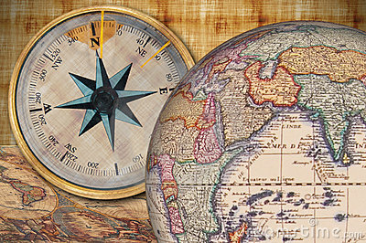**1) What is your topic?**

Ex: Basketball, Investments, Ants, Lightening, etc

**2) What is your aim?**

Be explicit: My aim is….

**3) What are the math connections are you planning to make?**

Be specific.

Bad answer: Functions

Good answer: Transformations of quadratic functions

Bad answer: Stats

Good answer: Measures of central tendency

Bad answer: Trig

Good answer: Sin & cos Law

**4) What are some things that you may have to research in order to answer your aim?**

**5) What are the definitions you will need to define for people not familiar with this topic?**

**6) What are some possible visual representations (graphs, tables, diagrams,…) that you might want to have?**

**7) How will you show personal engagement?** TIPS FOR WRITING A GOOD MATH EXPLORATION!

* Do not identify yourself, the school, the teacher, etc anywhere on your paper. Your name should only appear in the file name.
* You must have a cover page with the title of your exploration and the number of pages.
* Include page numbers.
* Introduction should be written in future tense and the conclusion in the past.
* Start with a brief introduction that explains your topic. Then state your aim and rationale. Be explicit: My aim is…. My rationale is…
* While doing your research, keep a record of each website you visited and include the date you access the site.
* If using a survey to collect some data, the survey should be in an appendix.
* If using a survey, think about how many people you are selecting and how you are selecting them. Stick to non-subjective questions.

Ex: “How much sleep do you get in a night?” is not a good mathematical question as no one gets the same amount every night and how does one know exactly when they fell asleep.

Ex: “What is your favourite type of music?” will not get you numerical results.

* Any diagrams/graphs/pictures that you did not create must be cited directly underneath.
* Do not split a table over 2 pages. If it is more than one page long, find a way to condense it or put part of it in an appendix.
* For graphs you create, axes must include labels and units.
* Use proper math notation. No computer notation (*, ^, x, etc). In Word: Insert 🡪 Equation

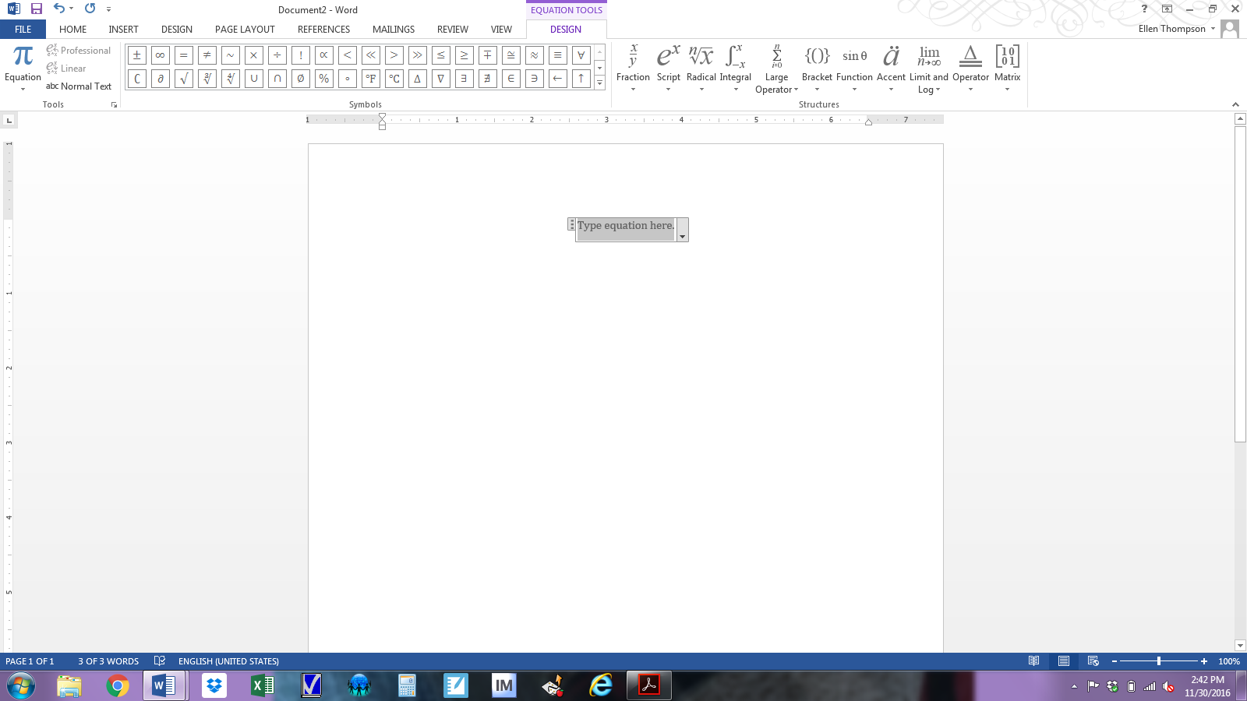

* Use $≈$ for any rounded values.
* If you need to round any decimal, you must justify your chosen degree of accuracy (how many Sig Figs places are relevant for your context). Explicitly discuss in your exploration why you chose the degree you did and why this is appropriate for your context.



For example, while a difference of one tenth may not matter if you are talking about speed of a locomotive, it could matter if you are talking about the amount of milligrams of morphine administered to a patient.

* Ask and answer personal questions (“I wonder if…, What if…)?. Make conjectures (an opinion or theory without sufficient evidence or proof) and compare once you have some data.
* Consider the historical and global perspectives of your topic.

Historical perspective: things that have happened with your topic in the past

Global perspective: the links between your own life and others throughout the world

* Reflect throughout not just in the conclusion. Every time you calculate a value, explain what it means in context.
* Discuss the implications of your results. Are they what you expected? What do they mean? Why are they important? How do they affect your life?...
* Discuss your results in the context of your topic, not just in general terms.

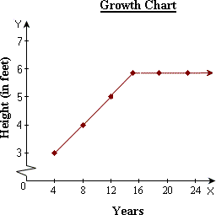Ex:

*~~The graph levels off at x > 15~~*

*The graph levels off after the age of 15 because that is the average age when girls tend to reach their maximum height.*

* Discuss possible limitations and/or extensions of your topic.

Limitation: a restriction, a defect or failing

Extension: an occurrence in another area

* Your conclusion should focus on the “answer” to your aim and the math involved.
* Your bibliography should be on a separate page.

EXPLORATION CHECKLIST

**Complete this checklist when you think you are finished**

**your draft but before you do your annotation.**

**Communication & Mathematical Presentation**

* Do you have a cover page with the title and page count?
* Do you have an explicit aim?
* Did you use 12pt double spaced font.
* Does the entire paper focus on the aim and avoid irrelevance?
* Does each new part of your exploration begin with some words to connect it to the previous part?
* Is your exploration coherent & concise?
* Did you cite all graphs, tables and diagrams directly underneath?
* Are the axes of your graphs properly labelled?
* Did you cite all references in your bibliography and acknowledge direct quotes appropriately?
* Did you use appropriate mathematical language and representation? (No computer notation *, ^, etc)
* Did you define key terms where necessary?
* Did you define all variables?
* Did you avoid splitting any tables over two pages?
* Did you use approximation signs for any rounded values?
* Did you justify your chosen degree of accuracy in relation to your topic?
* Do you have page numbers?
* Is your bibliography on a separate page?
* Is your survey (if you used one) in an appendix?

**Use of mathematics**

* Is your math at an SL/HL level?
* Have you shown that you *understand* the math you used? Simply doing math does not show you understand it.
* If you are doing regression, have you calculated it by hand as well as using technology?
* If you are doing a line of best fit, have you first verified that the data is indeed linear?
* **HL ONLY:** Have you shown both sophistication, precision, and rigor?

**Reflection**

* Did you ask questions, make conjectures and investigate mathematical ideas?
* Did you discuss the implications of your results? (What do they mean? Why are they important?...)
* Did you consider the significance of your paper? (How can the rest of mankind use your findings?)
* Did you discuss possible limitations and/or extensions of your topic?
* Did you make links between your topic and different fields and/or areas of mathematics?

**Personal engagement**

* Did you ask and answer personal questions (“I wonder if…, What if…)?
* Did you try to think independently and creatively?
* Did you address why you think your topic is interesting or why it appealed to you?
* Did you present mathematical ideas in your own way (as opposed to copy someone else’ theory)?
* Did you try to add “your voice” to the work?
* Did you consider the historical and global perspectives of your topic?
* Did you relate the results to your own life?

ANNOTATING YOUR DRAFT

Using the comment function in Word (or other programs), identify the items below in your exploration.

You must submit your annotated draft electronically as a PDF.

Please name your file as follows:

**FirstnameLastname_Math IA_Annotateddraft_May2021**

Ex: EllenThompson_MathIA_Annotateddraft_May2021

* Identify your aim
* Identify where you defined key terms.
* Identify where & how you used technology.
* Identify where you have discussed the degree of accuracy for your context.
* Identify everywhere you included personal engagement.
* Identify where you have discussed possible limitations.
* Identify where you have discussed possible extensions.
* Identify everywhere you have reflected.
* Identify where you have discussed the significance of your findings.
* Identify where you have asked questions and made conjectures.
* Identify everywhere you have used math at an SL/HL level.
* Identify where you showed understanding of the math you used.
* HL ONLY: Identify where you have shown sophistication in the math.
* HL ONLY: Identify where you have been rigorous with the math.

APPENDIX A: LINKS TO USEFUL IB DOCUMENTS

IB Citation guide: <http://bit.ly/2gEzt8Q>

IB Academic Honesty Policy: <http://bit.ly/2gLz9Z3>

APPENDIX B: MATH TECHOLOGY RESOURCES



Great software for working with geometry [www.geogebra.org](http://www.geogebra.org)



Awesome & free graphing website. **https://www.desmos.com/**



Fabulous resource for quick tutorial on many math topics. <http://www.khanacademy.org/>



A mathematical computation tool .[www.wolframalpha.com](http://www.wolframalpha.com)