Summer activities
For German 2 future German 3 or IB
German 3 will be a fast moving class. I do not have time to review a lot of material we have a lot of material to cover in order to get ready for the IB exam. For students enrolled in the IB program It is not just recommended but also necessary in order to be successful in the class.

I do have a few summer assignments prepared. They are located in a google classroom. (because Managebac is usable over the summer) . But I also would like to have once a month meeting in person or virtual. We will talk more about it in google classroom or on group me.
Here is the log in information.
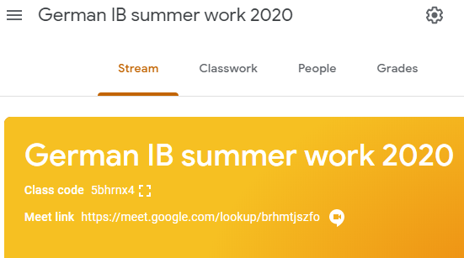

Like the lower classes you should review vocabulary on :
Choice 1: (this is what both of my sons have to do this summer)
Duolingo https://www.duolingo.com/learn
I may use this next year in the class room. So, if you want you already can place yourself in the class and do not lose the progress you make of the summer. This ist he classroom code: 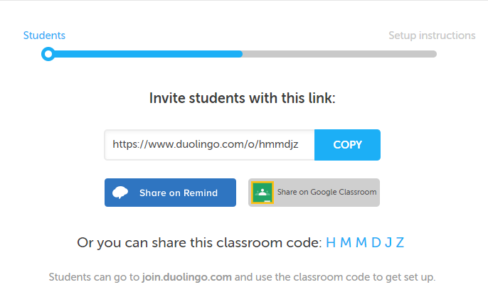

If you chose this summer option, I recommend that you test your skills, so you do not have to waste your time on the easy material.
You should complete 10 minutes 3x week or more if you want to.
You also can read these very easy books in duolingo. These stories are very easy and use previously learned vocabulary. This series may be to easy for you.

And / or Choice 2:
Go on this online German curriculum “Nicos Weg” https://learngerman.dw.com/en/beginners/c-36519789
It uses little real life clips to use the vocabulary in real life. It seems very fun with tons of real German listening.

And / or Choice 3:
Quizlet. Not having enough vocabulary is the biggest complaint of students. So, I added some IB required vocabulary in your class. See how much you study.

Other useful options
- are switching you phone to German language.
- You can text me in German (email me if you are interested and I’ll give you my cell phone number)
- Listen/watch German
  - slow spoken news https://www.newsinslowgerman.com/
  - “Easy German” an orginal German series with subtitle https://www.youtube.com/watch?v=B3LagCVBKKc&list=PL5v4Ks2M10W32EMeA0m6THOHV74pB-zQ8&index=42&t=498s
  - Or any other slow spoken German audio https://www.youtube.com/watch?v=Ge7ePECXAEk
  - Or switch Netflix to german and watch a previously seen show in German. I recommend that you start with children shows, because they generally use easier vocabulary.
  - Watch or listen to German you tube clips. Start easy with pepper pig, mickey mouse, sponge bob or anything similar to it.

- Review grammar via
  - Mr Asby https://www.youtube.com/watch?v=bGcgbzOGmYo&list=PL5v4Ks2M10W32EMeA0m6THOHV74pB-zQ8&index=17&t=0s
  - Or Learn German https://www.youtube.com/watch?v=gzRJfybj3a4&list=PL5v4Ks2M10W32EMeA0m6THOHV74pB-zQ8&index=8

