Summer activities
For German 1 future German 2
I highly recommend that you do a little bit German over the summer. Next fall we have to a quick recap the material we “covered” during the e-learning. That does not leave us with a lot of time to review any other material. So, highly recommend that you look at some German material over the summer.

Choice 1: (this is what both of my sons have to do this summer)
Duolingo https://www.duolingo.com/learn
I will use this next year in the class room. So, if you want you already can place yourself in the class and do not lose the progress you make of the summer. This ist he classroom code: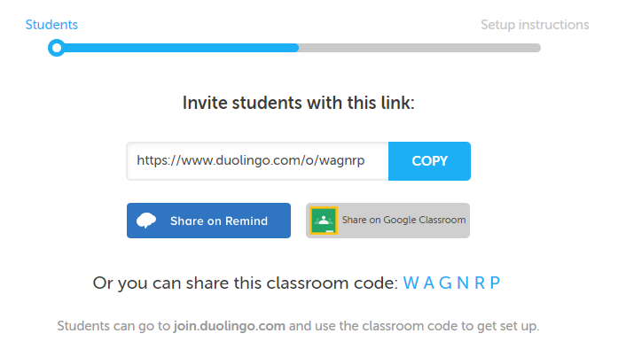

If you chose this summer option, I recommend that you test your skills, so you do not have to waste your time on the easy material.
You should complete 10 minutes 3x week or more if you want to.
You also can read these very easy books in duolingo. These stories are very easy and use previously learned vocabulary.

Choice 2:
Go on this online German curriculum “Nicos Weg” https://learngerman.dw.com/en/beginners/c-36519789
It uses little real life clips to use the vocabulary in real life. It seems very fun with tons of real German listening.

Other useful options
- are switching you phone to German language.
- You can text me in German (email me if you are interested and I’ll give you my cell phone number)
- Watch or listen to German you tube clips. Start easy with pepper pig, mickey mouse, sponge bob or anything similar to it.

